## Basics

free

open source

Linus Torvalds

### Open source:

1. sell
2. sell, recipe open
3. free, recipe closed
4. free, recipe open

Richard Stallman

AT&T BELL

MULTICS

UNICS

UNIX

Linux

Sun Solaris

AIX

Darwin

HP-UX

Xenix

Free BSD

GNU General public license

Red Hat (94)

Mint

Fedora Core

Open Suse

Debian Linux

Kali Linux

Ubuntu Linux

Raspbian

command prompt

command line interpreter (CLI)

terminal

### SHELL

sh

ksh

csh

tcsh

zsh

fish

bash

bourne again

stephen bourne



## Files Directories

### file structure

inverted tree structure

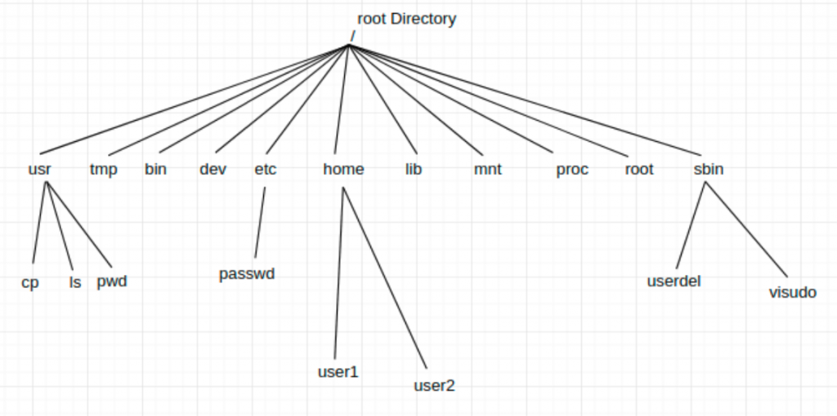

absolute path

relative path

cd

.. parent

. current directory

~ home folder

cat

nl

less

more

head

tail

### commands

1. builtin
2. executable file

### man

1 commands

2 system calls

3 functions

7 signal

### sys calls

chmod

getpid

getppid

signal()

### pipes |

### editors:

vi (vim)

gedit

atom

nano

sublimetext

vscode

emacs

notepad++

### vi editor

i insert mode

esc command command

commands:

:w save

:wq save & quit

:w! save as (need to give file name)

:q! quit without saving

:set nu set line numbers

yy copy

4yy copies four lines

p pasting

dd cut

delete

u undo

ctrl+r redo

## Users and Groups

### files

training.data

user group others

r w x r w - r - -

1 1 1 1 1 0 1 0 0

7 6 4

r read

w write

x execute

u user (owner)

g group

o others

dc.txt

r w - r w - r - -

6 6 4

r w - r w - r w -

6 6 6

chmod 666 dc.txt

chmod +w dc.txt

chmod o+w dc.txt

chown

chgrp

john, jane

root

super user

admin

su

sudo

useradd -m ashok

/home/ashok

passwd ashok

useradd -m ashok -p janedoe

sudo groupadd dv

usermod -a -G dv ashok

usermod -g dv ashok

### directories

r list names of files/directories

ls

w create or delete files

x cd

## process

### important terms:

pid

ppid

init

systemd

ps

-ax

-ef

-C give the name

-o customise the output columns

-p pid

-H hierarchy

pid

ppid

tty (terminal)

%cpu

%mem

time (actual CPU time)

etime (elapsed time)

stime (start time)

cmd (name or location)

uid

gid

user

rss (resident set size, non-swapped physical memory)

vsz (virtual mem size)

lwp thread ids

nlwp number of threads

psr CPU id

pri priority

stat (state of a process)

pstree

### jobs

process which go into the background of a terminal

job ids

jobs

fg

### states of a process

R run

S sleep (wait)

T stop (suspended, hibernation, pause)

I (idle) kernel

D uninterruptible

Z zombie

+ needs an output (display)

s session leader

## signals

kill

kill -9

|  |  |  |  |  |  |
| --- | --- | --- | --- | --- | --- |
|  | behaviour ? | keyboard | handle | core dump |  |
| SIGTERM | terminate | no | yes | no |  |
| SIGINT | terminate | ctrl+c | yes | no |  |
| SIGKILL | terminate | no | no | no | 9 |
| SIGSTOP | stop | ctrl+z | no | no |  |
| SIGQUIT | terminate | ctrl+\ | yes | yes |  |
| SIGCONT | continue | no | yes | no |  |

## misc commands & features

wc

-l

-c

-w

grep

### links

ln

hard link

symbolic